Neural Networks

**Unit 1: Basics of Neural Networks**

• Mathematical expressions of activation functions.

• Types of neuron models taught in lectures.

• Learning types, architectures and biological models of a neuron.

**Unit 2: Learning Rules and Pattern Recognition**

• All learning rules, including **Q-learning**, in detail as taught in class.

• Numerical problems based on: Linearly separable and non-separable patterns.

**Unit 3: Statistical Learning and Adaptive Filters**

• Statistical learning.

• Adaptive filter theory.

• Function approximation.

• Method of steepest descent.

• Least mean square (LMS) algorithm.

• Perceptron convergence theorem.

**Unit 4: Backpropagation and CNNs**

• Introduction to backpropagation algorithm & XOR problem.

• Heuristics for improving backpropagation algorithm performance.

• Convolutional Neural Networks (CNNs).

**Unit 5: Associative and Hopfield Networks**

• Hopfield network.

• Hamming network.

• **Associative Learning:**

• Auto-associative and hetero-associative memory.

• Bidirectional associative memory (BAM) model for pattern recognition.

• Numerical problems on Hopfield and associative memory models.

Unit - 1

**1. What is a Neural Network?**

A neural network is a class of mathematical algorithms represented graphically as directed graphs. It is inspired by biological neural networks found in living organisms, though the correspondence is loose. It consists of interconnected nodes mimicking neurons that process and transmit information.

**2. What are the components of a biological neuron?**

• Dendrite: Receives incoming signals.

• Soma (Cell Body): Processes input signals and decides if the neuron should fire.

• Axon: Transmits processed signals to target cells.

• Synapse: The connection between an axon of one neuron and the dendrites of another.

**3. What are the conditions necessary for a neuron to fire?**

A neuron fires when the excitatory impulses exceed inhibitory impulses by a threshold value, typically around 40mV.

**4. What is the McCulloch-Pitts model of a neuron?**

The McCulloch-Pitts model involves binary inputs (0 or 1) representing the absence or presence of an impulse. The output is determined based on a threshold using a simple rule: the weighted sum of inputs must exceed for the neuron to fire. It can perform basic logical operations like AND, OR, and NOT.

**6. How do biases affect neural networks?**

Bias enables affine transformation, allowing the activation potential to adjust independently of the origin. This flexibility enhances the network’s learning capability.

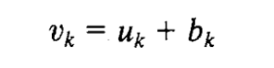

Where, b_k is the bias added to the linear combination of inputs.

u_k, allows for a shift in the activation function’s output.

**7. What are the types of neural network architectures?**

• **Single-layer feedforward network:** Contains one layer of output neurons; strictly acyclic.

• **Multilayer feedforward network:** Includes one or more hidden layers for extracting higher-order statistics.

• **Recurrent network:** Features feedback links for dynamic learning and memory.

**8. How is knowledge represented in neural networks?**

• Similar inputs yield similar internal representations.

• Different classes have distinct representations.

• Significant features should involve many neurons.

• Prior knowledge and invariances should be built into the network to simplify learning.

**9. What is the significance of weight sharing in neural networks?**

Weight sharing ensures that multiple neurons use the same weights for their connections, reducing redundancy and improving efficiency. It is often used alongside receptive fields to simplify the network’s structure.

**Exam:**

**1. What is the role of Activation Function in Neural Networks? Compare Two Activation Functions.**

**Role:**

**•** Activation functions introduce non-linearity, enabling the network to learn complex patterns. Without them, the network would be linear and unable to perform tasks like classification and image recognition.

**2. Compare Biological and Artificial Neural Networks. What is the significance of the Weights used in ANN?**

**Comparison:**

| **Aspect** | **Biological NN** | **Artificial NN** |
| --- | --- | --- |
| **Structure** | Neurons and synapses | Nodes and weighted connections |
| **Learning** | Through synaptic changes | Through weight adjustments via training |
| **Signal** | Electrical impulses | Numerical values between layers |

**Significance of Weights:**

• Weights control the strength of connections between neurons, adjusting during training to minimize error and improve predictions.

**3. Elaborate Feedback Neural Network Architecture. State at least one application using a feedback network.**

Feedback Neural Network:

• Networks with cycles, where information loops back to earlier layers, useful for sequential tasks like time series.

Application:

• Speech Recognition: RNNs help process speech by remembering previous words, improving accuracy over time.

Unit - 2

#### **1. What is meant by linear separability in neural networks?**

* **Answer:** Linear separability refers to the ability to separate data points of different classes using a straight line (in 2D), a plane (in 3D), or a hyperplane (in higher dimensions).
  + A dataset is **linearly separable** if such a separation is possible.
  + If no hyperplane can separate the classes, the dataset is **non-linearly separable.**

#### **2. Why is linear separability important for perceptrons?**

* **Answer:** Perceptrons can only solve problems where the data is linearly separable because they rely on a single layer of weights to compute a hyperplane.
  + Example: XOR problem is non-linearly separable and cannot be solved by a single-layer perceptron.

Non-linearly separable problems require multi-layer networks and non-linear activation functions. Single-layer perceptrons fail to solve such problems due to their inability to create non-linear decision boundaries.

Exam:

**Q1. List Any Four Types of Learning Methods and Their Associated Learning Rules**

1. Supervised Learning:

• Learning Rule: Perceptron Rule, Delta Rule, Backpropagation

• Learning Signal: Error between desired and actual output.

2. Unsupervised Learning:

• Learning Rule: Hebbian Learning, K-means Clustering

• Learning Signal: Similarity or distance between input vectors.

3. Reinforcement Learning:

• Learning Rule: Q-learning, Temporal Difference (TD)

• Learning Signal: Reward or penalty received after an action.

4. Self-organizing Learning:

• Learning Rule: Kohonen’s SOM (Self-Organizing Map)

• Learning Signal: Activation of the most similar neuron in the network.

Unit 3

1. **Q: What does the statistical nature of the learning process refer to?**

**A:** It refers to how learning algorithms use statistical principles to make predictions or decisions based on data.

1. **Q: Name some key components of statistical learning theory.**

**A:** Data sampling and distribution, model fitting (MLE, OLS), overfitting and regularization (L1, L2), hypothesis testing, and evaluation metrics like precision, recall, F1-score, and ROC-AUC.

1. **Q: What is the PAC model?**

**A:** The Probably Approximately Correct (PAC) learning framework defines a learning algorithm as PAC-learnable if it can generate a hypothesis close to the true concept with high probability (1−δ) within a specified error tolerance (ϵ).

1. **Q: Define δ and ϵ in the PAC model.**

**A:** δ is the confidence level, and ϵ is the error tolerance.

1. **Q: Who proposed the perceptron, and what is its significance?**

**A:** Rosenblatt proposed the perceptron in 1958 as the first supervised learning model for classification tasks.

1. **Q: What kind of patterns can the perceptron classify?**

**A:** It can classify linearly separable patterns.

1. **Q: What is an adaptive filter?**

**A:** It is a system that adjusts its parameters automatically based on an error signal to optimize performance.

1. **Q: What are the two processes involved in adaptive filtering?**

**A:** Filtering and automatic adjustment of synaptic weights.

1. **Q: Name three methods used in unconstrained optimization.**

**A:** Steepest Descent Method, Newton’s Method, and Gauss-Newton Method.

1. **Q: What is the goal of unconstrained optimization in adaptive filters?**

**A:** To minimize the cost function concerning the weight vector.

1. **Q: What does the Least Mean Square (LMS) algorithm aim to achieve?**

**A:** It aims to minimize the mean square error between the desired output and the system output.

1. **Q: What is a learning curve?**

**A:** It is a plot of the mean-square estimation error versus the number of iterations, showing the convergence behavior of the algorithm.

1. **Q: What does the Perceptron Convergence Theorem state?**

**A:** It guarantees that if the data is linearly separable, the perceptron algorithm will converge to a solution within a finite number of iterations.

1. **Q: How is the perceptron related to the Bayes classifier in a Gaussian environment?**

**A:** Both are linear classifiers, but the Bayes classifier minimizes classification error probability, whereas the perceptron is non-parametric and adaptive.

1. **Q: What is the main assumption of the Bayes classifier for Gaussian distributions?**

**A:** The features are distributed according to a Gaussian distribution.

Exam:

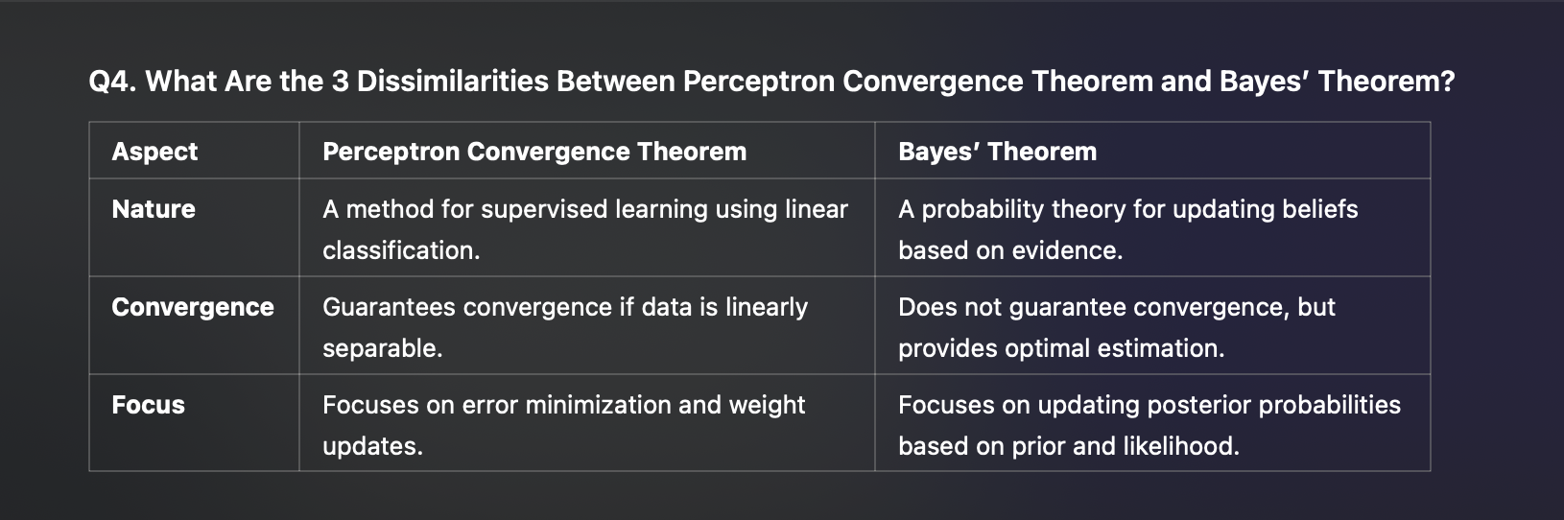

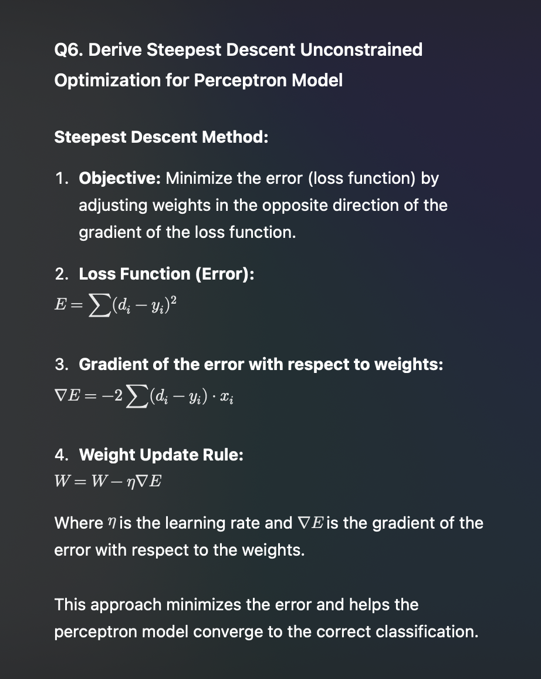

Unit 4

1. **Q: What is a Multilayer Perceptron (MLP)?**

**A:** An MLP is a feedforward neural network consisting of an input layer, one or more hidden layers, and an output layer. It generalizes the single-layer perceptron to solve complex tasks using error backpropagation for training.

1. **Q: What are the key characteristics of an MLP?**

**A:** Nonlinear activation functions, one or more hidden layers for feature extraction, and high connectivity via synapses.

1. **Q: Why can’t a single-layer perceptron solve the XOR problem?**

**A:** The XOR problem is not linearly separable, so it requires a hidden layer with nonlinear transformations.

1. **Q: How can the XOR problem be solved using an MLP?**

**A:** By introducing a single hidden layer with two neurons that transform the input into a space where XOR is linearly separable.

1. **Q: What is the purpose of the backpropagation algorithm in MLP?**

**A:** It adjusts the synaptic weights based on the error signal in a two-pass process: forward pass (weights fixed) and backward pass (weights adjusted).

1. **Q: Name some heuristics to improve the backpropagation algorithm.**

**A:** • Sequential updates for large datasets

• Sigmoid activation functions

• Normalizing inputs

• Choosing optimal initial weights and learning rates.

1. **Q: What is the role of hidden neurons in MLP?**

**A:** Hidden neurons act as feature detectors, transforming input data nonlinearly into hidden spaces to extract relevant features for classification or regression.

1. **Q: What is the role of the Hessian matrix in neural networks?**

**A:** It influences backpropagation learning dynamics and serves as the basis for network pruning through second-order optimization methods.

1. **Q: What is the purpose of cross-validation in neural networks?**

**A:** To ensure the model generalizes well by determining the best number of hidden neurons and when to stop training.

1. **Q: What are common techniques for network pruning?**

**A:** Complexity-regularization, weight decay, weight elimination, and Hessian-based pruning.

1. **Q: List some advantages of backpropagation learning.**

**A:** • Efficiency and scalability

• Versatility across neural network types

• Supports nonlinear activation functions.

1. **Q: What are common limitations of backpropagation learning?**

**A:** • Susceptibility to overfitting

• Vanishing/exploding gradients

• High computational cost.

1. **Q: What is a Convolutional Neural Network (CNN)?**

**A:** A specialized class of neural networks designed to recognize patterns in two-dimensional data like images, using operations like convolution and subsampling.

1. **Q: What are the main stages in a CNN?**

**A:** Feature extraction, feature mapping, and subsampling.

1. **Q: How does convolution help in edge detection?**

**A:** Convolution with specific kernel filters detects edges by identifying intensity changes in vertical, horizontal, or diagonal directions.

Unit 5

1. **Q: What does the Kolmogorov theorem state in the context of neural networks?**

**A:** The theorem states that any continuous function can be represented as a superposition of continuous functions of one variable and addition.

1. **Q: Who developed the Hopfield neural network, and what is its primary use?**

**A:** Developed by Dr. John J. Hopfield in 1982, it is used for associative memory and optimization tasks.

1. **Q: What are the key features of Hopfield networks?**

**A:** • Bidirectional and symmetric connections

• Binary or bipolar neurons

• Ability to recover patterns from partial or noisy inputs.

1. **Q: What is the role of the energy function in a Hopfield network?**

**A:** The energy function ensures that the network minimizes its energy to converge to a stable state corresponding to a stored pattern.

1. **Q: What is the Hamming Neural Network, and what does it use for classification?**

**A:** It is a type of ANN that uses Hamming distance, measuring differences between binary vectors, for pattern recognition and classification.

1. **Q: What are the main layers in a Hamming Neural Network?**

**A:** • Input Layer: Receives binary vectors.

• Competitive Layer: Computes Hamming distance.

• Output Layer: Identifies the closest match.

1. **Q: What is the Hamming Neural Network, and what does it use for classification?**

**A:** It is a type of ANN that uses Hamming distance, measuring differences between binary vectors, for pattern recognition and classification.

1. **Q: What are the main layers in a Hamming Neural Network?**

**A:** • **Input Layer:** Receives binary vectors.

• **Competitive Layer:** Computes Hamming distance.

• **Output Layer:** Identifies the closest match.

1. **Q: Where is the Hamming Neural Network commonly applied?**

**A:** Pattern recognition, error correction in communication systems, and associative memory.

1. **Q: Describe the architecture of a multilayer neural network.**

**A:** It consists of an input layer, one or more hidden layers, and an output layer.

1. **Q: What are the main steps in the backpropagation algorithm?**

**A:** • Forward pass: Compute function signals and activation outputs.

• Loss computation: Use error metrics like MSE or cross-entropy.

• Backward pass: Compute gradients using the chain rule and update weights.

1. **Q: What is associative learning in neural networks?**

**A:** It is the ability of a neural network to form associations between input and output patterns.

1. **Q: Name different types of associative learning in neural networks.**

**A:**  • Supervised Learning

• Unsupervised Learning

• Reinforcement Learning

• Hebbian Learning

• Self-Organizing Maps (SOMs)

1. **Q: What is SVM-based learning?**

**A:** It involves using Support Vector Machines to find an optimal hyperplane for classification tasks by maximizing the margin between data points of different classes.

1. **Q: What is tree-based learning in neural networks?**

**A:** It refers to techniques that use decision tree structures for learning and making predictions, often integrated into ensemble methods like Random Forests and Gradient Boosted Trees.

Exam:

**Q1. Identify and briefly describe the neural network model which recognizes the distorted input pattern correctly during testing (The model was trained with undistorted input pattern during training).**

The Autoassociative Memory Network (also known as the Autoencoder) is commonly used for recognizing distorted input patterns correctly during testing.

• Training Phase: The network is trained with undistorted patterns.

• Testing Phase: During testing, the network is presented with a distorted version of the input. The network attempts to recall the undistorted pattern from the noisy or incomplete input. This is done by reconstructing the input from the learned representations.

Example:

• Input Pattern during Training: [1 0 1 1]

• Distorted Input during Testing: [1 ? 1 1] (missing one value)

• The network can use its learned weights to fill in the missing value during testing.